LESSON TITLE: "Value - An Egg and an Eraser" (2
Lessons)
TIME FRAME: 2 - 3 weeks
LEVEL: Advanced Middle School to Beginner High
School

OBJECTIVES
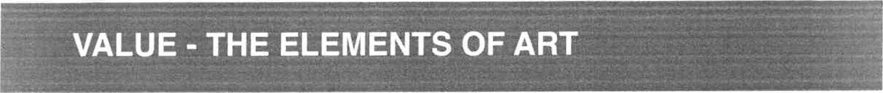
MATERIALS FOR THIS LESSON:
Part One
- Soft graphite pencils • White drawing paper
- Hard boiled eggs
Part Two
- White drawing paper,

18' by 24'
Vine charcoal • Black compressed charcoal
- Kneaded eraser Paper towels i soft cloths
- Still life with spotlights

The student will learn the concept of value in terms of art. The student will learn the importance of value in the development of drawings and paintings.

DESCRIPTION
Part One
Students will use their knowledge of value to draw an egg from observ^{t}ation on white drawing paper using soft graphite. The focus should be to create an accurate rendering of the egg using smooth gradations of value in order to create the illusion of form and light source.
Part Two
Students will create a "highlight rendering" of a spotlit still life using vine charcoal, compressed black charcoal, and a kneaded eraser. Students should demonstrate an understanding of the full use of value in a drawing in order to create the illusion of form and light source.

VOCABULARY
Value - In terms of art, value is the darkness or lightness of a color.
Tints - Tints are lighter values of a color.
Shades - Shades are darker values of a color.
Light Source - Location from which light is emitted.
Chiaroscuro - A drawing and painting effect of applying contrasting values in order to create the illusion of light source.
KEY POINTS / ESSENTIAL QUESTIONS
- What is value?
- How are tints and shades different?
- How are tints and shades used to create the illusion of form and light source(s)?
- Why is value important to drawing and painting?

GUIDED PRACTICE
The teacher will present the presentation entitled "Value". The presentation exposes students to the concepts of value, tints, shades, highlights, and shadows. Students are also made aware of how these contribute to the illusion of form and light source in a drawing or painting.
Part One
Students will be provided with one hard boiled egg to use as subject matter for an observational drawing. Students should place the egg on a sheet of white drawing paper on their tables and draw the egg from observation using soft graphite. Students should avoid the use of line and focus on creating the illusion through the use of value only. Effort should be made to create smooth transitions of value from dark to light in order to accurately create the illusion of form and light source in the drawing. (See project example below.)
Part Two
Students will begin by covering a sheet of white drawing paper with soft vine charcoal using the side of the stick. The charcoal will be spread into the surface using soft cloths or paper towels in our to create an even coverage of medium gray. Then, using a kneaded eraser, students will begin to erase out the image using a centralized still life setup as a reference that has been lit with spotlights. Students should focus on erasing out the highlights of the image with the eraser. Students can then go back and add areas of darker values with the vine and compressed charcoals to complete the image. The focus in this assignment is to again create a full range of value in order to create the illusion of form and light source in the drawing. (See project example below.)
